Silverleaf Nightshade in Young Pistachio Orchards
Jorge Angeles, Weed Management Advisor, Tulare, Kings, and Fresno Counties
Silverleaf Nightshade, Solanum Elaeagnifolium, is perennial weed that is native to South America, Mexico, American Southwest and Southern States. This herbaceous and woody summer weed belongs to Solanaceae just like other weeds such as black nightshade (Solanum nigrum), hairy nightshade (Solanum physalifolium) and horsenettle (Solanum carolinense). It can be found throughout California and in grows in desert and semi-arid areas. Silverleaf nightshade is often found growing in different cropping systems, rangeland, pastures, roadsides, and disturbed areas. Silverleaf nightshade is highly adaptable and can tolerate a wide range of soil and climatic conditions such as high temperatures, low rainfall, saline and drought conditions. The leaves and berries produced by silverleaf nightshade plants have glycoalkaloid compounds that can be toxic to livestock and humans if consumed (UC IPM) (Boyd 1982).
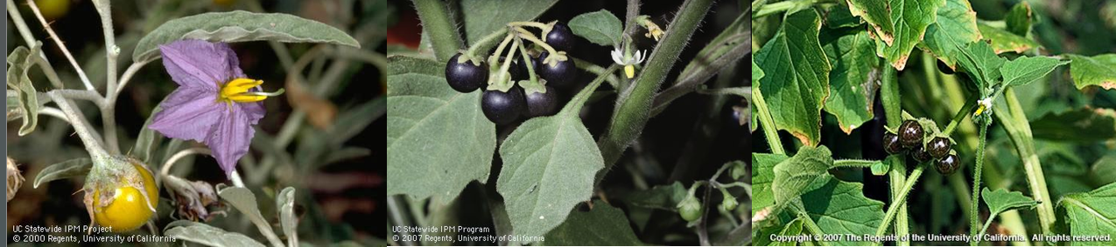
Figure 1. From left to right: Silverleaf Nightshade (Solanum Elaegnifolium), Black Nightshade (Solanum Nigrum), Hairy Nightshade (Solanum Physalifolium). Weeds in the nightshade family can be found in orchards and in annual crops. Silverleaf Nightshade produces silver green leaves, violet flowers, and yellow berries. Black and hairy nightshades produce white flowers and black berries. UC IPM.
Life Cycle
One of the main reasons why silverleaf nightshade is difficult to control in orchard crops is due to its perennial life cycle. From early spring to late summer, silverleaf nightshade will germinate and emerge from seeds and rhizomes from previous year (Figure 4). In the summer and early fall, silverleaf nightshade will grow between 1-3 feet and produce deep violet flowers with yellow centers (UC IPM). During its flowering stage, Silverleaf nightshade produces widespread root systems that potentially can germinate new plants with wet soil moisture conditions. One silverleaf nightshade plant has the potential to produce about two hundred yellow to brown berries and each berry contains between 24 to 150 seeds (Roberts and Florentine 2022). In the winter, silverleaf nightshade plants will die with the first frost but the root systems will survive and produce new vegetative shoots in the spring. Seeds can be spread by birds consuming the
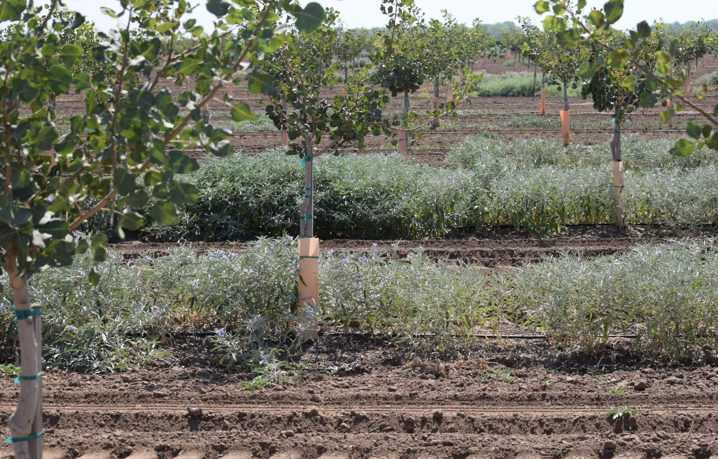
Figure 2. Silverleaf Nightshade (Solanum Elaeagnifolium) in a Pistachio Orchard in Tulare County.

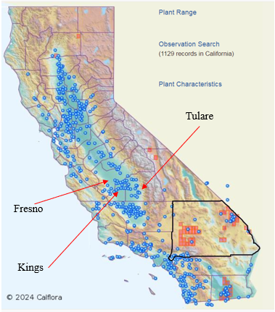
Figure 3. Silverleaf Nightshade (Solanum Elaeagnifolium) CA Distribution Map. The blue dots show the distribution of Silverleaf nightshade in California. CALFLORA 2024
berries and tillage operations. In addition, tillage operations during the spring can contribute to the spread rhizomes of silverleaf nightshade across fields. Precautions need to taken into account when doing soil disturbance operations in the spring and summer.
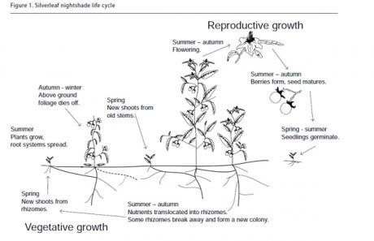
Figure 4. Silverleaf Nightshade (Solanum Elaeagnifolium) Life Cycle. NSW Department of Primary Industries.
Impacts
Silverleaf nightshade is becoming a problematic weed in some young pistachio orchards in Tulare, Kings and West Fresno. This perennial weed is mostly found in young orchards that are planted on west Fresno and Kings County by interstate 5 highway (Figure 3). In Tulare County, silverleaf nightshade is found pistachio orchards that were planted in unmanaged fallow land or in fields near roadsides where it’s commonly found. One of the major impacts of silverleaf nightshade is that it competes with young pistachio orchard for resources such as water, light and nutrients. If left unmanaged, silverleaf nightshade can also interfere with irrigation operations and potentially reduce crop vigor in young pistachio trees (Figure 2). Since silverleaf nightshade can adapt to alkaline and saline soils, it will also outcompete many of the summer annual weeds and become the dominant weed in the population.
Management
Silverleaf nightshade can be a weed that is difficult to control with the available management methods in orchards. Tillage is not recommended as that is one of the ways that rhizomes can be spread across the orchard (Ensby 2011). Mechanical control methods such mowing can be an effective control method to prevent weeds from setting seed. Flail mowers are often used in orchards and vineyards to mow weeds in between tree rows. It is important to note that, new silverleaf nightshade shoots will potentially sprout from the root system after the tops are mowed (Stanton 2011). Even though mowing can be an effective weed control method during the growing season, most commercial mowers will miss the weeds that grow in between trees that directly compete with young trees. Hand weeding can be used to remove some of the weeds around the trees, but extra precaution needs to be taken. Mature silverleaf nightshade plants are covered in reddish prickles that can be harmful if weeds are handled with bare hands. Weeding tools such as shovels and hula hoes can damage surface drip hoses if the user is not careful.
Herbicides can be an effective weed management method to control silverleaf nightshade in different tree crops. There are a twelve pre-emergent and thirteen post-emergent herbicides with
Post-Emergence Herbicides |  |  | Pre-Emergence Herbicides
Group  # | Herbicide | Registration | Group  # | Herbicide | Registration
4 | 2, 4-D | Bearing, Non-Bearing | 3 | Oryzalin | Bearing, Non-Bearing
14 | Carfentrazone | Bearing, Non-Bearing | 3 | Pendimethalin | Bearing, Non-Bearing
1 | Clethodim | Bearing, Non-Bearing | 2 | Orthosulfamuron | Bearing, Non-Bearing
14 | Saflufenacil | Bearing, Non-Bearing | 14 | Flumioxazin | Bearing, Non-Bearing
1 | Fluazifop-P-Butyl | Non-Bearing | 29 | Indaziflam | Bearing, Non-Bearing
10 | Glufosinate | Bearing, Non-Bearing | 21 | Isoxaben | Bearing, Non-Bearing
9 | Glyphosate | Bearing, Non-Bearing | 27 | Mesotrione | Bearing, Non-Bearing
2 | Halosulfuron | Bearing, Non-Bearing | 14 | OxyFluorfen | Bearing, Non-Bearing
1 | Sethoxydim | Bearing, Non-Bearing | 2 | Rimsulfuron | Bearing, Non-Bearing
22 | Paraquat | Bearing, Non-Bearing | 2/14 | Penoxsulam | Bearing, Non-Bearing
14 | Pyraflufen | Bearing, Non-Bearing | 2 | Flazasulfuron | Bearing, Non-Bearing
22 | Diquat | Non-Bearing | 14 | Sulfentrazone | Bearing, Non-Bearing

Table 1. Herbicides registered for use in CA tree and vine crops. https://wric.ucdavis.edu/. Mention of a trade name is not an endorsement or recommendation. Always check the label before applying.
different sites of action that are registered for use in pistachios (Table 1). Pre-emergent herbicides are normally applied during the dormant season and most only control weeds before they germinate. Pendimethalin, rimsulfuron, mesotrione, flumioxazin, isoxaben, and flazasulfuron are herbicides that have great control over black and hairy nightshade. Isoxaben can suppress silverleaf nightshade, but cannot be used in pistachios that have not been established for at least three years. Pre-emergent herbicides will not control silverleaf nightshade that emerges from rhizomes in the summer. Post-emergent herbicides can be used to control silverleaf nightshade that emerges in the summer and early fall before harvest. Glyphosate, glufosinate, pyraflufen, and carfentrazone are post-emergent herbicides with different sites of action that can be used to control different weeds and can be used up to two weeks before harvest. 2, 4-D is another post-emergent herbicide that is registered for use in pistachios, but needs to be applied to trees that have been established for at least one year and has a pre-harvest interval of 60 days. Research work from other researchers has shown that glyphosate and 2, 4-D have excellent control of silverleaf nightshade (DiTomaso 2013) (Gitsopoulos 2017). Glyphosate is a systemic herbicide that can potentially kill the root system of silverleaf nightshade, when applied at the correct timing and rate. Since Silverleaf nightshade has extensive rhizome root systems, the root systems need to be killed to fully control this weed. In the summer months, a combination of mowing and the use of post-emergent herbicides can kill the aboveground tissues of silverleaf nightshade weeds and deplete the root bank in the soil (Heap 2018). Post-emergent herbicides need adjuvants such as nonionic surfactants, crop and seed oils, to increase their efficacy. Furthermore, always consult the herbicide labels on information regarding information on the required adjuvants, pre-harvest intervals, application rates and maximum applications per seasons.
The weed management tools to control silverleaf nightshade in pistachio orchards are limited. Developing and maintaining field records before planting is a great way to determine the history of a field before planting. Conducting weed surveys in the winter and spring can help determine what weed species are present in a field. Silverleaf nightshade populations can be reduced by mowing in between tree rows and applying herbicides to weeds present in between trees. These management practices need to be done before the weeds set seeds to contribute to reduce the seedbank. To avoid introducing silverleaf nightshade to other fields, it is important to sanitize tractor equipment and manage the weeds that grow on the field edges or near irrigation canals (. To have an effective silverleaf nightshade management program, a combination of herbicides with different modes of action are needed decrease the possibility of it developing herbicides resistance. Silverleaf nightshade is difficult to control because of its tolerance to many herbicides (Gitsopoulos 2017). During the summer months, it is best to use a combination of systemic and contact post-emergent herbicides to get higher levels of control for silverleaf nightshade. To enhance the efficacy and herbicide absorption, post-emergent herbicides require adjuvants such as methylated seed oils, non-ionic surfactants, crop-oil concentrates, and nitrogen-based fertilizers.
Cited Literature
Boyd, J.W. and Murray, D.S. 1982. Growth and development of silverleaf nightshade (Solanum elaeagnifolium). Weed Science 30, 238-43.
DiTomaso, J.M., G.B. Kyser et al. 2013. Weed Control in Natural Areas in the Western United States. Weed Research and Information Center, University of California. 544pp.
Ensbey R. 2011. Noxious and environmental weed control handbook – A guide to weed control in non-crop, aquatic and bushland situations. 6th ed. New South Wales: Department of Trade and Investment, Regional Infrastructure and Services.
Gitsopoulos, Thomas & Damalas, Christos & Georgoulas, Ioannis. 2017. Chemical options for the control of silverleaf nightshade (Solanum elaeagnifolium). Planta Daninha. 35. 10.1590/s0100-83582017350100064.
Heap, J. & Wu, H. 2018. Silverleaf Nightshade: Australian best practice management manual. Primary Industries and Regions SA & NSW Department of Primary Industries: Adelaide.
Roberts J., Florentine. 2022. Biology, distribution and management of the globally invasive weed Solanum elaeagnifolium Cav. (silverleaf nightshade): A global review of current and future management challenges. Weed Res. 2022;62:393–403. doi: 10.1111/wre.12556.
Stanton, R. & Wu, Hanwen & Lemerle, D. 2011. Root regenerative ability of silverleaf nightshade (Solanum elaeagnifolium Cav.) in the glasshouse. Plant Protection Quarterly. 26. 54-56.

General Irrigation Tips for Young Pistachios
Tobias Oker, Soils and Irrigation Advisor Kern County
Pistachio acreage in California has been steadily increasing in recent years. A recent report by the Administrative Committee for Pistachios puts the bearing acreage of pistachio in California at about 461,000 acres, and the non-bearing acreage at about 144,000 acres. The average acreage for new yearly plantings for the last five years is about 29,000 acres. Much of the new plantings are in areas in the southern San Joaquin Valley that have moderate to high salinity. Generally, young pistachio trees are those that of non-bearing age.
In California, pistachio is usually planted at row spacings of 20 to 22 feet and tree spacings of 15 to 20 feet. In ideal circumstances, the tree grows to cover most of this space by the time it reaches maturity. The amount of orchard space that the tree canopies shade at any given time is a critical component that goes into the estimation of how much water the trees need as they mature. For mature pistachio trees, the intermittent estimation of the crop water requirement (evapotranspiration) is relatively easier to determine due to the availability of research-developed water use curves (crop coefficients) for pistachio trees. In the southern San Joaquin Valley, a mature pistachio tree requires about 46 inches of water every season; with a peak daily demand of about 0.34 inches per day during hottest summer days. Research has shown that the evapotranspiration of tree crops generally tends to reach its maximum by the time the orchard floor area shaded by the tree canopies is between 50 and 60%. Young pistachio evapotranspiration is estimated by multiplying that of a mature tree by an adjustment factor. For example, the crop water demand of a first-leaf pistachio tree, on a peak evapotranspiration summer day is about: 0.34 in./day multiplied by an adjustment factor of 0.1, which yields a value of 0.034 inches per day. Adjustment factors for drip irrigated pistachio in the southern San Joaquin are as follows: 0.10 for year 1; 0.20 for year 2; 0.30 for year 3; 0.40 for year 4; 0.52 for year 5; 0.65 for year 6; 0.78 for year 7; 0.90 for year 8; 1.00 for year 9 and older. For more information on these adjustment factors, visit the website of the University of California Cooperative Extension Kern County Office.
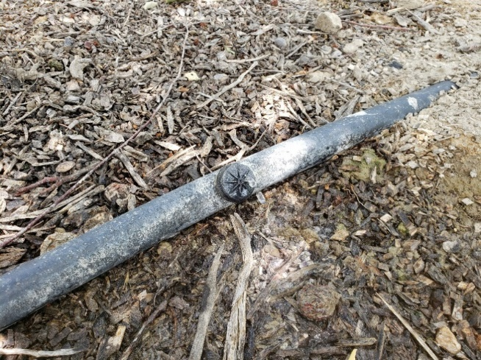
Like many orchard crops grown in California today, pistachio trees are mainly irrigated using microirrigation devices; which are designed to ensure irrigation efficiencies of at least 90% and above. Microirrigation devices operate at low pressures (3 to 20 psi), apply water at low rates (as low as 0.5 gph to highs of 10 to 20 gph), and more precisely compared other pressurized irrigation methods. Examples of microirrigation devices include: inline drip, micro-sprinklers and micro-sprays (sometimes called fan-jets), button drippers.
In the first years of its growth, a young pistachio tree spends most of its energy on vegetative growth. Its canopy is very small and only covers a small fraction of its assigned tree area; implying that it has a relatively small evaporative surface. To efficiently irrigate a young pistachio tree, it is important to ensure that water is directly applied to the area close to the base of the tree and is concentrated to the rootzone. This approach mitigates water and nutrient loss through deep percolation and/or evaporation, and is generally recommended for widely spaced crops. Effort should be made to avoid applying water to the spaces where there isn’t significant root growth – such as the midway point between successive young trees – and this can be achieved by selecting the appropriate irrigation device. For young pistachios, button drippers are recommended because they can be installed close to the tree. Button drippers usually have flow rates ranging from 0.5 to 2 gph. To install a button dripper, the irrigation lateral is punctured to create a small hole which is then plugged with the emitter. For newly potted trees, the dripper should be positioned to apply water directly to the root ball for about 30 days. After the roots have grown into the surrounding soil, one or two button drippers can be installed at least one foot off either side of the trunk. As the tree grows each year, additional button drippers are added onto the lateral; much further away from the trunk. It is important to take note of the flow rate of the drippers, peak evapotranspiration of the tree and soil water holding capacity vis-à-vis state of root growth, when deciding the number of emitters to install as the tree grows. If a grower prefers, the button drippers could be replaced by micro-sprinklers or micro-sprays when the trees are mature and/or when most of the orchard canopy is closed.
To promote root growth in young established trees, it is recommended that they are not frequently irrigated as an imposition of mild stress conditions spurs roots to grow in search of water and nutrients. However, newly transplanted trees may require more frequent irrigation during the initial stages while their roots grow into their immediate soil surroundings. In irrigation practice, the amount of water applied, when it is applied, is determined by the water storage capacity of the managed rootzone, and in accordance with an allowable water depletion rate. This is called irrigation scheduling. The rootzone water storage capacity is mainly determined by soil texture. It is therefore important to find out what type of soil is found in the orchard when determining an irrigation schedule. This is especially important when microirrigation methods are managed to apply water only to the rootzone of young trees. Light (sandy) soils tend to have lower lateral water redistribution and retention capacities. In such soils, more frequent but low volume irrigation may be recommended. On the other hand, very heavy clay soils – though having higher water retention abilities – may also require frequent irrigation because a significant bit of much of the water stored in them is not available to the trees. Soils with the highest water storage capacity tend to be silt-loams.
Figure 1 Button dripper installed on an irrigation lateral
To aid irrigation management, it is recommended that growers utilize soil moisture probes. These are widely available in the market. Stem water potential of young pistachio trees can be monitored using the hand-held pump-up pressure chamber since their stems are usually thin for high-tech plug-in sensors. Although there is no research developed baseline values of SWP for pistachio trees – unlike almonds for example –, it is recommended that the irrigation strategy for young trees should be to avoid prolonged conditions of water stress. To this, the SWP should be maintained between -9 to 10 bars often. It is also advisable to monitor soil moisture close to the base of tree and at multiple points of the rootzone. To do this, for an example, a probe could be placed within one foot of the tree or dripper, and soil moisture monitored at depths of one and two feet. If funds permit, and depending on the type to device chosen, a longer soil probe – 4 to 6 feet – could be installed to monitor moisture at greater depths, in the long run as the tree grows to maturity. In order to get an orchard-wide overview of the soil moisture status at any time, it is recommended to install several sensors at different locations within the field. To determine the number of sensors and installation locations within a field, a soil map such as that provided by as the USDA’s Web Soils Survey, or UC Davis’s SoilWeb application is helpful. Alternatively, a lab test of soil samples taken from different locations in the field, could be used to guide soil probe installation. Most sensors available in the market report soil moisture either as volumetric water content, or as a soil tension force. Irrespective of units, from an irrigator’s perspective, the values of interest are the field capacity and permanent wilting point of soil at the site and the reading returned by the probe at any given time. For orchards on loamy soils, moisture depletion up to the midpoint value between field capacity and permanent wilting point (or 50% moisture depletion), before resumption of irrigation is considered to be acceptable.
Lastly, the performance of an irrigation system can also be limited by the general state of the “health” of the soil of an orchard site. For example, soils which are highly compacted and/or sodic significantly limit soil water infiltration; leading to water loss. Therefore, when establishing new orchards in “tough” soils, it may be beneficial to carry out some practices to improve the physical, chemical and biological properties of the soil. This may involve actions like tilling to break soil crust, applying amendments to reduce salinity or sodicity and adding organic matter.
Many factors are part of the equation of economically sustainable pistachio production. Efficient water use is one of those, which is particularly important in a state like California where production is heavily reliant on irrigation.
For more information about pistachio irrigation, please call the UCCE-Kern Soils and Irrigation Advisor or visit the website of the University of California Kern County Cooperative Extension office.

Tobias E. Oker
Soils & Irrigation Advisor, UC Cooperative Extension, Kern County
University of California, Agriculture and Natural Resources
Office phone: (661) 868-6218 | Email: teoker@ucanr.edu

Further reading
Administrative Committee for Pistachios. (2024). 2023 Pistachio Statistics. https://acpistachios.wpenginepowered.com/wp-content/uploads/2024/01/2023-Pistachio-Statistics.pdf
Culumber, M., Zaccaria, D., 2021. 2021 Pistachio Irrigation: Mitigation Strategies for Drought. https://shorturl.at/iKMSZ
Doll, D. (2017). Pistachio Irrigation: Determining Water Needs and Managing Drought. UC ANR. https://ucanr.edu/sites/PistachioShortCourse/files/274447.pdf
Ferguson, L., & Haviland, D. R. (2016). Pistachio Production Manual (L. Ferguson & D. R. Haviland, Eds.). University of California Agriculture and Natural Resources. https://anrcatalog.ucanr.edu/Details.aspx?itemNo=3545
Goldhamer, D. A. (n.d.). Tree Water Requirements and Regulated Deficit Irrigation. Retrieved March 20, 2024, from https://ucanr.edu/sites/fruitandnut/files/73693.pdf
International Nut & Dried Fruit Council. (2024). Production share of pistachios worldwide in 2022/2023, by country. Statista. https://www.statista.com/statistics/933042/global-pistachio-production-by-country/
Niederholzer, F. (2022). Potted Tree Irrigation After Planting: Getting the First Year Right. https://www.sacvalleyorchards.com/almonds/irrigation/potted-tree-irrigation-2022/
Sanden, B. (2018). Pistachio ET by age. University of California Cooperative Extension, Kern County. https://cekern.ucanr.edu/Irrigation_Management/Pistachio_ET_by_age/
United States Department of Agriculture; Natural Resources Conservation Service. (2013). Microirrigation. In NEH, Part 623, Irrigation, Chapter 7.

Carbohydrates, dormancy, and yield in pistachios
Katherine Jarvis-Shean, UCCE Orchard Advisor, Sacramento, Solano and Yolo Counties
Maciej A. Zwieniecki, Dept Plant Sciences, UC Davis

Spring is often a time of unknowns and speculation. Did we get enough chill this winter? Will we have strong budbreak this spring? What are yields going to look like this fall? One relatively new area of research, carbohydrate dynamics, is shedding light that may help answer these questions. Recent years of research by the Zwieniecki lab (the Z Lab) at UC Davis, including the Carbohydrate Observatory, have been providing exciting new insights to better explain how pistachios may be counting winter chill, when budbreak occurs, and how much pistachios will yield in a given year. While many areas remain to be investigated, this research is starting to provide insight into how management can influence carbohydrates, which in turn influence dormancy, budbreak and yield.
What Are Carbohydrates?
A few definitions are helpful before we dive into discussion. Non-structural carbohydrates (NSC) are carbohydrates that are not part of structures like cell walls. NSC are utilized by the tree for energy, as building blocks for cell growth, as an osmolyte to influence water dynamics, and as signals for multiple physiological activities. NSC are either in the form of sugars or starch. Sugars are the product of photosynthesis, and the building blocks of starch. Sugars are also an active part of biological cell activity and their level in cells are under strict control. Starch is the storage form of carbohydrates and can later be broken down to provide sugars.
How Do Carbohydrates Vary Over the Year?
An intensive sampling was conducted of carbohydrates of almonds, pistachios and walnuts in the twig, branches and trunk over the course of a year. As has been seen in other temperate trees, it was found that NSC varies with changing stages of growth or phenology, and concurrent climatic conditions. NSC decreases following bud break, reaches the lowest levels during the growing season, and then increases starting mid-to-late summer to reach maximum levels in fall or early winter (Figure 1). By following the amounts of NSC in a plant over time, we can build a better understanding of how trees are using carbohydrates for current opportunities (vegetative and fruit growth) or future challenges (dormancy, defense against pathogens and other stressors).
Carbohydrate Dynamics Predict Bloom
Exactly how trees track the accumulated experience of winter cold and spring heat to “know” it’s time to break dormancy in the spring has remained somewhat mysterious. The Carbohydrate Observatory has found that in almonds, pistachios, and walnuts, shortly before bud break, there is a surge in starch and a dip in sugar concentration. The Z Lab has used this knowledge to create a model for bloom timing, based on fall and winter carbohydrate and temperature dynamics. This bloom prediction model integrates some important aspects about how plants balance sugar and starch concentrations. When it is warm, trees turn sugars into starch, and when it’s cold, trees turn starch into sugar. For trees to keep sugar levels in an optimum range, they adjust the concentration of the enzymes responsible for this starch synthesis and degradation. Because starch synthesis is very temperature sensitive, but starch degradation is not, trees can quickly respond to too much sugar at warm temperatures but can’t respond as quickly to too little sugar. When conditions warm up in the spring, starch synthesis quickly takes off, pulling sugars out of circulation, resulting in a dip in sugar. This dip in sugar and upsurge in starch is predictive of (and may even trigger) bud break.

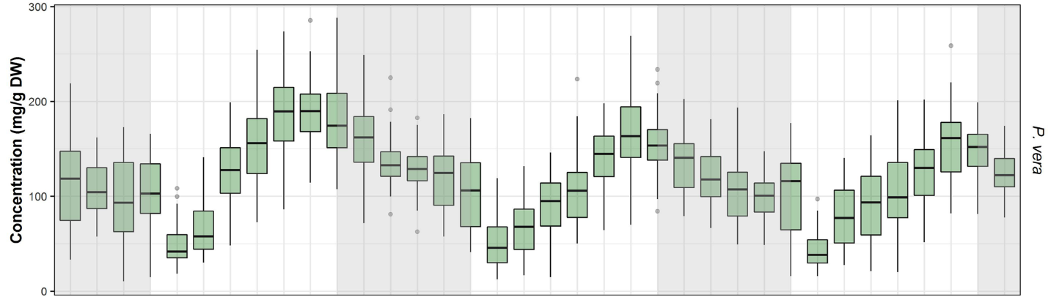
Figure 1. Average concentration of NSC (sugars and starches) from more than 40 pistachio orchards from January 2017 to December 2019. The center bar of each green box shows the average for that month, the box shows the zone where half of all the values from that month lie (25% above and below the average) and the whisker lines show more extreme values. Grey shading reflects the dormancy period. (Davidson et al., 2021. Sci. Reports)
Because of the different temperatures sensitivities of the different enzymes, cold winters, somewhat counter-intuitively, would amplify accumulation of starch synthesis enzymes, resulting in less warm time necessary in the spring to trigger a sharp sugar drop and bloom. Warmer winters would downregulate starch synthesis, requiring more warmth than normal in the spring to achieve low sugar levels. By integrating this knowledge of the principles of carbohydrate dynamics and specific thresholds and ranges learned from the Carbohydrate Observatory, pistachio budbreak was predicted within 7 days on average (Sperling et al 2021). While this may not be accurate enough for management decisions, it’s close enough to support integrating these carbohydrate dynamics into our understanding of how trees count the passing of winter and spring.
Using this model, they could then extrapolate the impacts of sugar concentrations going into winter. Going into winter with higher sugars, a metric of having built up higher NSC reserves over the growing season, results in earlier bloom, functioning almost like having experienced more chill. Lower sugars results in later bloom. This is supported by other recent research (Amico Roxas et al, 2021), that found that early defoliation in the fall decreased NSC going into winter and delayed budbreak in the spring, whereas girdling branches in October (which keeps more carbohydrates in the shoots) moved budbreak earlier.
Carbohydrates and Yield
Because carbohydrates are both the energy currency of plants and are used to make structures like cell walls, they are critical to growing pistachio fruit during the summer. NSC concentrations stay low during the growing season, as the carbohydrates made by photosynthesis get channeled into growing the crop, and sometimes into growing vegetation. New research is showing this interplay of carbohydrate sinks, photosynthesis and nitrogen demands may help explain alternate bearing habits of pistachio. UCCE Orchard Specialist Giulia Marino has recently looked into these dynamics by either partially defoliating bearing branches to reduce carbohydrate sources, or partially stripped off growing fruit to reduce carbohydrate sinks. She found that branches with a lot of leaves relative to the number of fruits actually increased photosynthesis during kernel fill, presumably in response to the strong carbohydrate demand of nearby fruit. However, branches with a lot of fruit set decreased photosynthesis after kernel fill. This may seem counter-intuitive (shouldn’t they ramp up photosynthesis even more?), until they found that nitrogen in the leaves of those branches was decreasing at the same time that photosynthesis was dropping. This is likely because nitrogen was remobilized from the leaves to the kernels, hindering the nitrogen-related components of the photosynthetic process. Why does this concern us, from a production standpoint? Because this change would then result in lower carbohydrate availability for buds being created for the following year’s crop, leading to alternate bearing.
Relatedly, Dr Zwieniecki, looking across almonds, pistachios and walnuts data from the Carbohydrate Observatory and yields provided by growers, sought to see if there was a relationship between NSC in different months of the year and yield (Zwieniecki et al 2023). He found that in pistachios there’s a strong, consistent correlation between NSC in wood and bark in the fall and winter (October through March) with yield the following year, particularly the starch component of total NSC,. This relationship was most pronounced in December, shortly after leaf drop. The higher the starch in the wood of pistachio twigs, the higher the yield turned out to be the following year. Given Marino’s findings of how carbohydrates relate to alternate bearing, this high starch-high yield relationship is likely in part a matter of correlation – following a low set “off” year, Marino’s research indicates you’d go into winter with more female flower buds and more carbohydrates. However, higher winter NSC was also found to be related to higher yields in almond and walnut, which don’t have this alternate bearing complication. This indicates that yields are likely also higher following a high carbohydrate winter because there’s more gas in the carbohydrate tank to fuel the growth needs of the crops the following season.
What’s this all mean for production?
The relationship between chill, heat and carbohydrates helps us understand why warm winter temperatures, and warmed wood and buds in low fog winters lead to delayed and protracted budbreak. This also explains why chemical sprays that interfere with respiration (cells turning sugar into energy) and reflectants (e.g. kaolin clay) that keep wood temperature lower could help compensate for lower chill. More work is needed to help fine tune the use of this knowledge, say to know how warm temperatures need to be to make reflectants worth the expense, or when the optimal time is for spraying dormancy breaking treatments.
The strong relationship between high NSC going into winter, strong yields and normal bloom timing suggest that late season management that helps send orchards into dormancy with higher amounts of NSC leads to positive outcomes of budbreak timing and yield. Irrigation and foliar disease management that can keep leaves healthy and producing new sugars well into October should benefit this NSC accumulation. Stresses that lead to early defoliation would have the opposite effect. The next step in research is to look into other factors can influence this relationship (Variety or rootstock selection? Nutrient management to keep leaves healthy and photosynthesizing?), and whether they have enough influence to merit the expense.

Early season leaf sampling can help you stay on your fertilization target
Phoebe Gordon, orchard systems advisor for Madera and Merced Counties

Did you know that there is a tool that will help you identify whether your orchard is deficient in nitrogen or potassium with enough time to fix things in THIS growing season? It is called early leaf sampling and it can help you fine tune your nitrogen and potassium fertilization program, especially in the case of an unusually good or bad crop set.
Before I get into the leaf sampling protocol, I want to explain a bit about nitrogen and potassium in soils, and the physiology of nitrogen and potassium in pistachio trees.
Nitrogen and potassium in soils
No matter in what form nitrogen is applied to the soil, it will eventually be converted into nitrate, a form that is vulnerable to leaching losses from the root zone. Because of this, understanding when nitrogen is needed by pistachios and how much is needed will allow you to minimize N losses and maximize your return on fertilizer investment.
Nitrogen can be applied to soils in many forms. It can be found in organic matter amendments (compost, manures, many organic fertilizers), conventional fertilizers, and irrigation water. Soil organic matter also releases nitrogen, as do any cover crops that are grown in the orchard and release nutrients as they break down over time.
Nitrogen that is incorporated into organic matter is the “original” source of nitrogen in ecosystems, and is the main way nitrogen is applied to certified organic orchards. Organic matter must be broken down by soil microbes, or mineralized, before it is available for uptake. The resulting form is ammonium. Urea, while not a certified organic product, is an organic compound because it contains a carbon atom. Ammonium is then nitrified – converted into nitrate. The nitrogen contained in ammonium, like organic matter, is immobile in soils, while nitrate is mobile. Urea, while an organic compound, is actually very mobile as it is small and uncharged and can move rapidly through the soil.
Mineralization and nitrification (conversion of ammonium into nitrate) are done by soil bacteria, which work fastest in warm, well aerated but moist soils. This means that, at least in deciduous orchard crops, conversion of nitrogen from immobile to mobile forms happens most rapidly when nitrogen is needed by plants – during the warm periods of the year.
Table 1: summary of forms of nitrogen and behavior in soils.
 | Organic matter/compounds | Ammonium | Nitrate
Plant available? | Mostly no¹ | Yes | Yes
Soil mobe? | Mostly no² | No | Yes
Conversion rate | Years-weeks³ | Weeks-days | N/A
¹There is evidence that plants can take up amino acids, however it is unlikely that they are a significant source of nitrogen as they would be rapidly mineralized by soil bacteria
²Urea is very mobile until it is mineralized into ammonium
³Some soil organic matter is very resistant to breakdown by soil bacteria and will remain stable for decades or longer. This can be a source of nitrogen, however we are referring to more easily broken down sources like composts, manures, and cover crops

Potassium is mostly immobile in soils as it can adsorb to negatively charged soil particles. The ability of a soil to hold onto potassium and other positively charged ions is called the Cation Exchange Capacity (CEC). It is generated by clays and organic matter. Because of this, the CEC tends to be small in sandy soils and large in clay soils. Potassium can be somewhat mobile in sandy soils that have a small CEC, but is generally considered to be mostly immobile in soils.
Potassium fertilization has been covered before here and won’t be discussed extensively in this article. In general, different potassium fertilizers have not been found to differ when it comes to plant uptake and usage – applying potassium in the wetted zone of your orchard is the most critical part of ensuring potassium fertilizer is available for uptake. This is because root activity is primarily in the wetted zone during the growing season. Banding in the same location annually can be very effective, however these bands should be placed carefully to ensure the fertilizer lands in the wetted zone. Fine roots that take up nutrients can be found at very shallow depths in microirrigated orchards, so a fall band that is moved into the soil via rain will provide potassium to your trees.
The specific form of potassium fertilizer does matter when it comes to fertigation. Unless you buy potassium fertilizer that is already in liquid form, most sources of potassium tend to be fairly insoluble and can take a lot of water to dissolve. While formulations that are better for injection tend to be more expensive than forms that are typically used for soil applications, I’ve heard from several folks that the expenses associated with banding often mean that fertigating, even if the fertilizer is more expensive, is more cost effective. Fertigated potassium will move more in the soil than banded potassium.
Potassium, like nitrogen, can be found in composts and manures. Unlike nitrogen, potassium is very available in carbon-based amendments like composts and manures because it is not bound up into permanent structures.
Since it will stay put in most soils, potassium can be applied the previous fall, though many growers have great success with potassium by treating it like nitrogen and fertigating it throughout the season. This is especially true in potassium fixing soils.
Nitrogen and potassium in pistachios
Nitrogen is critically important for almost all plant processes. It’s a part of DNA and amino acids, and therefore involved in basically everything a plant does. Because of this, it is needed in large quantities as plants grow and develop their fruit. Because of its mobility, applications should be split between fruit set and harvest.
Pistachio nitrogen uptake is dictated by plant need. In immature trees, this is primarily growth, and in mature trees, it is primarily the crop load. Mature trees also need some nitrogen to supply vegetative growth but it typically pales in comparison to the amount that is needed for the crop. Pistachios require 28 pounds of nitrogen per 1000 lbs of marketable yield and about 25-30 lbs to supply vegetative growth. Since pistachios are alternate bearing, their yield demand will be different for an ON or OFF year.

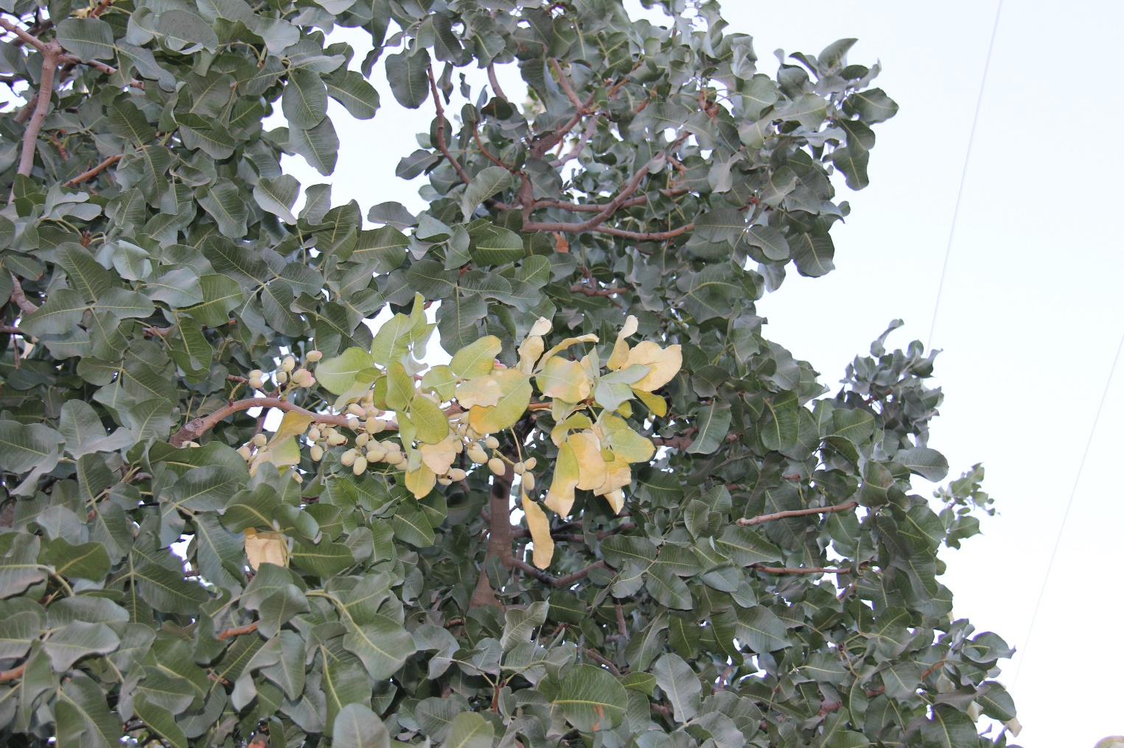
Image 1: leaf nutrient deficiencies in an ON branch, resulting from such strong demand from developing nuts that stored nitrogen and potassium are being pulled from leaves.
Nitrogen uptake in pistachios is primarily driven by crop load and will vary whether the orchard is in an ON or OFF status. In heavily alternate bearing rootstock-scion combinations like Kerman on P. atlantica (which hasn’t been planted in a very long time), nitrogen demand could be so strong in an ON year that nitrogen stores in plants would be tapped during nut fill, and uptake would be heavier the following spring as the trees recovered. Alternate bearing is less in Golden Hills/Lost Hills and with the higher vigor UCBI rootstocks, and so the depletion of nitrogen from other tissues in ON years is probably less.
It may be tempting to think that plant nitrogen status drives alternate bearing, but our current data suggests it is more likely carbohydrate starvation of buds during ON years (the developing fruit demands a lot of photosynthesized sugars, too!). Nitrogen may very well play a role, however only hedging and pruning have been found to reduce alternate bearing in existing orchards by changing the composition of ON and OFF branches that are present on individual trees.
Potassium is not incorporated into plant structures, for the most part. It is involved in cellular processes such as enzyme function, and critically, maintaining osmotic balances in cells. It is also needed in large quantities by nut crops. Pistachios require about 45 lbs of K (55 lbs of K₂O) per 1000 lbs of marketable yield and 25-30 lbs of K₂O to supply vegetative growth.
Potassium uptake in pistachios is fairly straightforward: over 90% of uptake happens during nut fill, regardless of the bearing status of the tree. Like nitrogen, uptake will be greater in an ON year than an OFF year. Ensuring that your potassium fertilizer has been applied before nut fill is critical to ensure that there is enough available in soils to supply plant demands.
Managing nitrogen in an orchard
Nitrogen and potassium fertilization should start with a good assessment of 1) your block’s yield potential, and 2) what you think the current season’s yield will be.
The yield potential is based off the yield history of a site. While pistachios can yield as much as 6000 lbs in an ON year, in many locations soil texture, soil chemistry, and water quality will limit the yield potential of specific sites. Accurately assessing the yield potential of an orchard is important for correctly assessing nitrogen fertilization rates. Aspirational nitrogen applications cannot help an orchard overcome a yield limitation such as high salinity or a restricted root zone.
Year to year events will also change the yield potential of a block – whether it is in an ON or OFF year, bloom conditions, and boron fertilization status are some examples. Unfortunately, accurately predicting yield at bloom is far more of an art than a science – you probably won’t land on exactly the right number but you’ll probably be in the general area. This, however, is not good enough for generating accurate fertilizer recommendations!
Early season leaf sampling will help you determine whether your fertilization programs are on track. Leaf sampling should occur approximately 35-45 days after full bloom (roughly early to mid-May). Sample 10 subterminal leaflets from each tree, and sample trees that are at least 25 yards apart. A full nutrient panel is required for the prediction tool. It is important to note that this tool predicts what your July leaf tissue values will be, and it is essential to still sample in July to check that your possible course corrections worked.
The Fruit and Nut Research and Information Center has an online tool that you can use to guide nitrogen and potassium fertilizer applications, and will allow you to enter your early leaf sampling results to guide later season applications. A step-by-step walkthough can be found below:
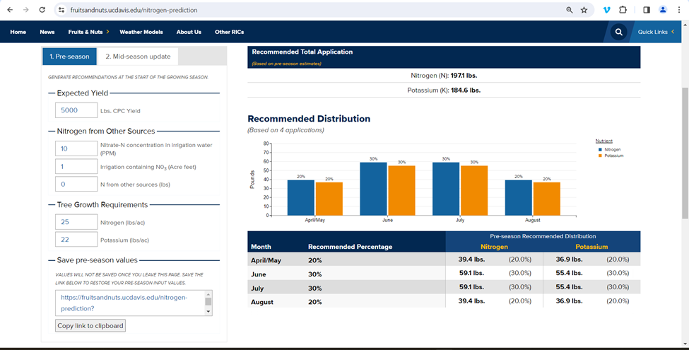
Figure 2: The pre-season tab and fertilization suggestions
The pre-season section (on the left of the photo) will allow you to enter your expected yields, any nitrogen adjustments that need to be made, and what you would like to apply to supply tree growth. Note that potassium is in the form of the element, not K₂O.
Once you have your leaf tissue results, plug them into the “mid season update” tab, along with your updated predicted yield and fertilization thus far, and the tool will give you a graphical representation of your expected yields. If your early-season nitrogen levels indicate low levels in July, the tool will provide you with updated fertilization rates to get back on track.
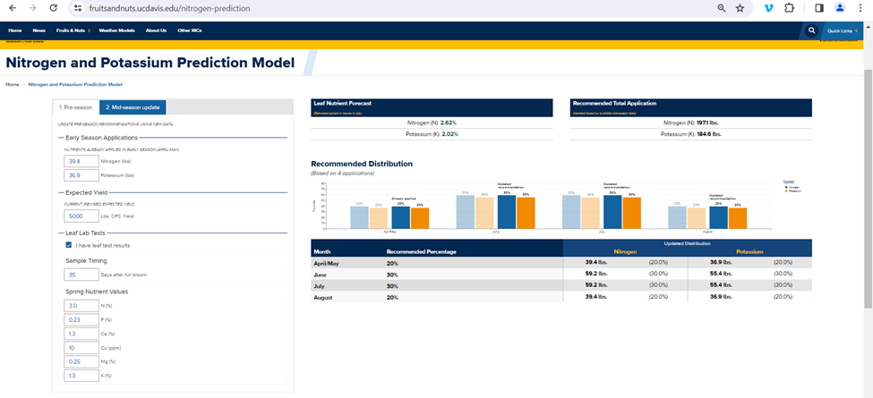
Figure 3: The mid-season update tab showing suggested fertilization rates based off of adequate early season nitrogen values

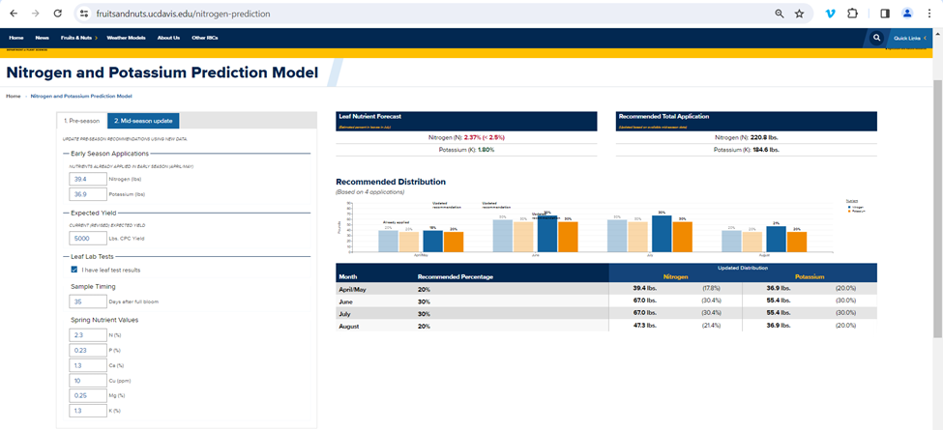
Figure 4: The mid-season update tab showing suggested nitrogen and potassium fertilization rates based off of low leaf nitrogen levels
Notes on leaf sampling
Leaf sampling is an imperfect tool – plant nutrient status can vary widely across an orchard, and the recommended best sampling methods aim to get an “average” picture of a block. However, we all know that an orchard block is anything but uniform! Until we get better yield mapping and site-specific fertilization tools, most blocks will receive one rate of nitrogen and potassium. While one leaf sample for a block doesn’t capture variability, it does still fit with how we still manage our orchards.
If you are interested in zone-specific fertilization, we do have some limited tools: it is possible to apply foliar sprays or soil applications to particularly well yielding areas of the orchard – whether this is economically feasible will be determined by the specific costs of these practices in your operation and how much money you would save by cutting back fertilizer in areas that yield worse. For best effect, variable fertilization would also require additional leaf samples to ensure that you are on track with what the trees need.
The accuracy of leaf sampling is also vulnerable to poor sampling technique – bad sampling or storage practices will not give accurate values. I used to work in an agricultural testing lab and saw some wild things – leaves that were rotting and obviously had sat in the back of a truck for weeks, whole plants (including roots) pulled for a standard leaf tissue sample, and soil samples submitted in a used tennis shoe (?!?). While these are some of the extremes, a term used in computer science is applicable here: garbage in = garbage out.
Despite all of these issues, leaf sampling is the best tool we currently have for managing nitrogen and potassium fertilization, in addition to fertilizing based off of predicted yields. And, despite all its issues, it still is a useful tool for diagnosing deficiencies. I’ve diagnosed many an orchard with low yields as having boron deficiencies, and it can help with diagnostics in cases of potential herbicide drift!
Additional resources
https://fruitsandnuts.ucdavis.edu/nutrition-landing-page/pistachio-nutrition-information
https://www.cdfa.ca.gov/is/ffldrs/frep/FertilizationGuidelines/Pistachio.html

Save the date!

The 2024 Advances in Pistachio Production Short Course will be held November 5-7 in Visalia, California. Stay tuned for more information!

